## Azure Digital Twin

URL: <https://azure.microsoft.com/en-us/products/digital-twins/>

**Overview**

Azure Digital Twins is an Internet of Things (IoT) platform that enables users to create a digital representation of real-world things, places, business processes, and people. Gain insights that help users drive better products, optimize operations and costs, and create breakthrough customer experiences.

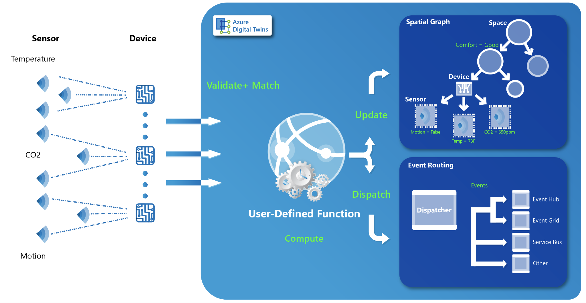

**Fig 1: Azure Digital Twin**

* Open modeling language to create custom domain models of any connected environment using Digital Twins Definition Language
* Input from IoT and business systems to connect assets, including IoT devices, using [Azure IoT Hub](https://azure.microsoft.com/en-us/products/iot-hub/#overview), [Logic Apps](https://azure.microsoft.com/en-us/products/logic-apps/#overview), and REST APIs
* Output twin change events to [Azure Data Explorer](https://azure.microsoft.com/en-us/products/data-explorer/), [Azure Synapse Analytics](https://azure.microsoft.com/en-us/products/synapse-analytics/), [Event Hubs](https://azure.microsoft.com/en-us/products/event-hubs/) and other downstream services

**How it works**

Data collection: Azure Digital Twin integrates with IoT devices to collect data and telemetry from the physical environment. This data is transmitted to the cloud through Azure IoT Hub.

Data processing: The collected data is processed in real-time using Azure Time Series Insights and other Azure services to extract insights and information.

Modeling: The data and insights are used to create a digital model of the physical environment using Azure Digital Twin. This model represents the physical environment as a set of interconnected entities, each representing a physical object or system.

Simulation: The digital model can be used to simulate and test scenarios in a virtual environment, allowing organizations to experiment and optimize their physical environments before making changes to the actual environment.

Control: The digital model can also be used to control the physical environment, for example, by triggering actions based on the state of the physical environment or by sending commands to IoT devices.

## IBM Watson IoT

URL:<https://internetofthings.ibmcloud.com/>

**Overview**

IBM Watson IoT Platform is a SaaS for device management, monitoring, and data storage. It provides users with an IoT system where they can build and extend apps to take advantage of IoT analytics and data from connected devices and sensors. In combination with IBM Cloud technologies, businesses can extract data that provides insights to improve operations and enable innovative business models.

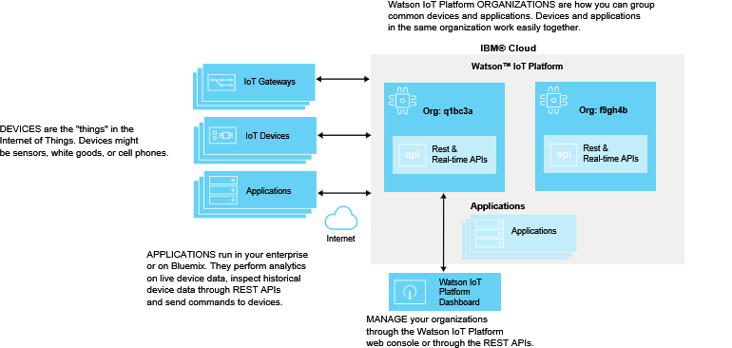

**Fig 2: IBM Watson IoT platform**

* perform device actions like rebooting or updating firmware, receive device diagnostics and metadata, or perform bulk device addition and removal.
* industry-standard MQTT protocol (OASIS ratified) to connect devices and applications. MQTT is designed for efficient exchange of data to and from devices in real-time.
* Securely receive data from and send commands to devices using MQTT with TLS to secure all communication between devices and this service.

How it works

Device Connectivity: Watson IoT provides a secure and scalable infrastructure for connecting and managing IoT devices. Devices can be connected using a variety of protocols, including MQTT, HTTP, and WebSockets.

Data Collection and Management: Watson IoT collects data from connected devices and stores it in a centralized repository for processing and analysis. The platform also provides tools for managing and organizing the data, including data tagging and categorization, data transformation, and data storage.

Data Analysis: Watson IoT provides advanced analytics capabilities, including machine learning algorithms, that enable organizations to gain insights from their IoT data. The platform also provides real-time analytics and visualization tools to help organizations quickly identify trends and patterns in their data.

Application Development: Watson IoT provides a suite of development tools and services that enable organizations to build and deploy IoT applications quickly and easily. The platform includes a library of pre-built components, such as APIs and data connectors, that can be used to create custom applications.

Device Management: Watson IoT provides a comprehensive set of tools for managing and maintaining connected devices, including device monitoring, firmware updates, and device diagnostics.

## 3. Google Cloud IoT Core

URL:<https://internetofthings.ibmcloud.com/>

**Overview**

Google Cloud IoT Core is a managed service for connecting, managing, and ingesting data from dispersed devices in an easy and secure way. In combination with other cloud services, users get a complete solution to collect, process, analyze, and visualize IoT data in real time so operations can be more efficient.

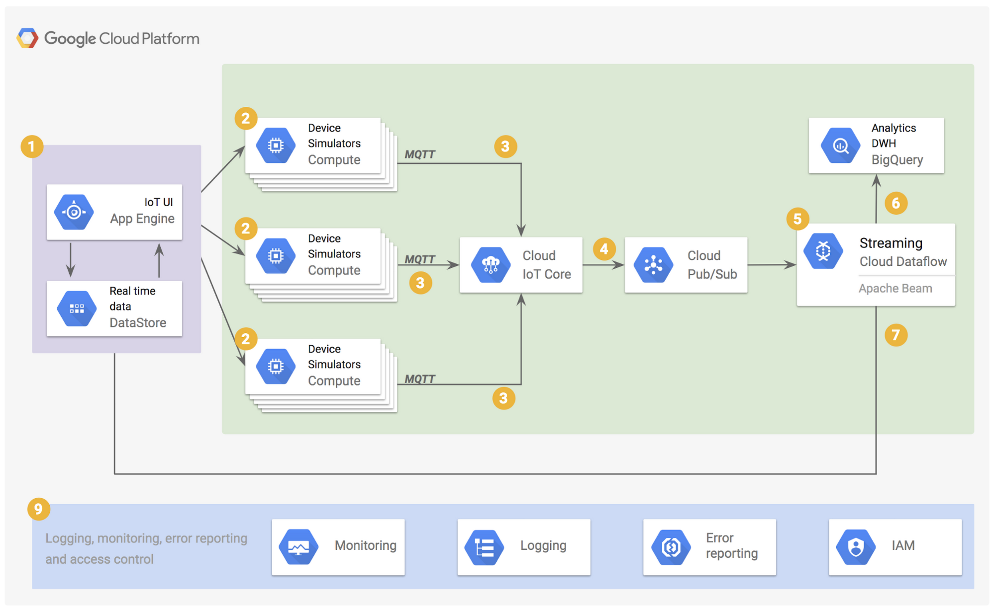

**Fig 3: Google Cloud IoT Core**

It supports

* ClearObject (Implementation partner)
* Quantiphi (Implementation partner)
* SoftServe (Implementation partner)
* SOTEC (Implementation partner)
* Aeris (Technology partner)
* ClearBlade (Technology partner)

How it works

* Google Cloud IoT Core runs on a serverless infrastructure, which scales automatically in response to real-time changes. It also adheres to stringent industry-standard security protocols that protect business data.
* It works out of the box with devices from leading hardware manufacturers. Businesses can reduce capital expenditures on IoT projects and maintenance costs with a pay-as-you-go service.

## 3 Other Platforms

| **Platform Name** | **URL** |
| --- | --- |
| Thingworx | <https://www.ptc.com/en/products/thingworx> |
| Fracttal one | <https://www.fracttal.com/en/fracttal-one> |
| AWS IoT Core | <https://aws.amazon.com/iot-core/> |